**BOOKMYSHOW APPLICATION**

**SCOPE**

Develop a booking application similar to BookMyShow, facilitating the booking of movie tickets, event tickets, and other entertainment-related services.

**User Roles & Functions**

1. **End User :**

* **Account management:**
* CRUD
* Login in/Log out
  + **Event Search:**
    - Search and filter events/movies by location, date, genre, etc.
    - View trending and recommended events
  + **Booking:**
    - Select event/movie and desired time slot
    - Choose seats from an interactive seating chart
    - Apply promotional codes or discounts
    - Booking added to user dashboard (can be canceled refund ticket raised)
  + **Payments: (good to have)**
    - Multiple payment options (credit/debit cards, wallets, net banking)
  + **Notifications: (reminder)**
    - Receive booking confirmation via email/SMS(not now)
    - Get reminders for upcoming events
  + **Feedback:(good to have)**
    - Rate and review attended events/movies

1. **Organizer :**

* **Account management:**
* CRUD
* Login in/Log out
  + **Event Management:**
    - Create new events with detailed descriptions and images
    - Update event details and availability
    - Set and adjust ticket prices
    - Manage seating arrangements and capacities
  + **Sales Monitoring: (good to have)**
    - Track real-time ticket sales and bookings
    - View booking trends and statistics
  + **Communication:**
    - Send updates and notifications to attendees
    - Reply to comments and reviews (can delete hide user reviews and comments)
  + **Financial Management:**
    - Access sales reports (good to have)
    - Manage refund for canceled shows or other financial settlements

1. **Admin Functions:**

* **Account management:**
* CRUD
* Login in/Log out
* Can manage user and organizer accounts as well
  + **User Management:**
    - Create, and delete user & organizer accounts
    - Assign roles (organizer, user, etc.)
  + **Event approval:**
    - Approve or reject event listings by organizers
  + **Customer Support:**
    - Monitor ticketing issues and resolve issues

**3.Verifier(out of scope)**

* **Verify Booking**
* Verify booking on reaching venue of event
* **Fetch Details**
* Fetch details of user’s booking in case of error

**4. Inter-Role Interactions**

* **End User & Organizer:**
  + Users can view and book events created by organizers
  + Users can provide feedback which organizers can respond to
* **Organizer & Admin:**
  + Organizers submit events for admin approval
  + Admins can help organizers with issues related to event listings and sales
* **End User & Admin:**
  + Admins provide customer support to users
  + Admins can handle disputes and refund requests from users

USER

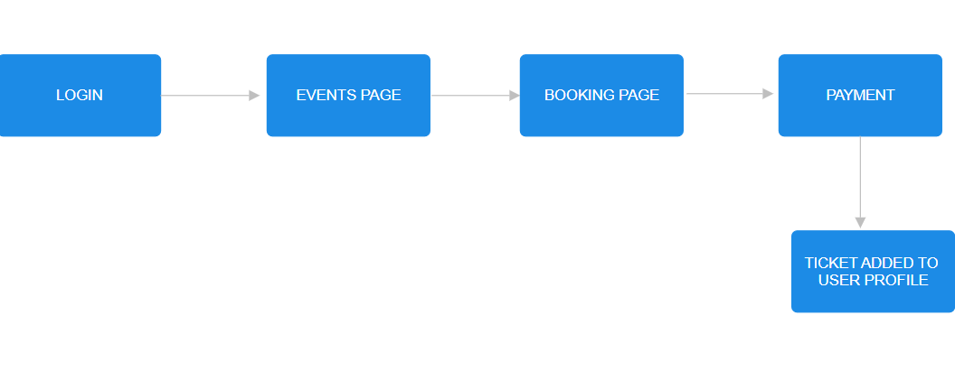

ORGANIZER

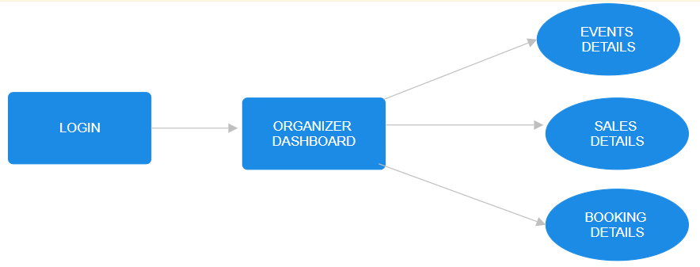

ADMIN

VERIFIER

